Question 1.1 -- Regression as minimization
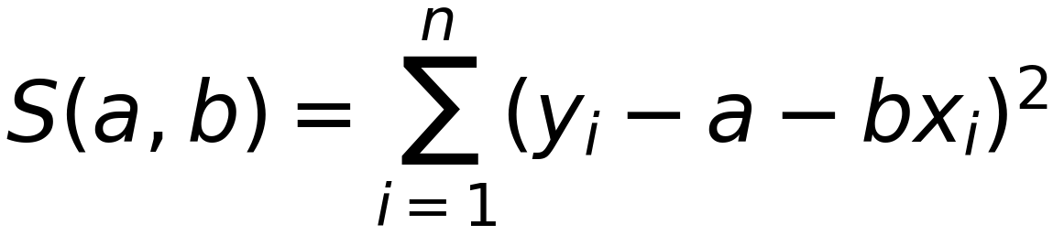
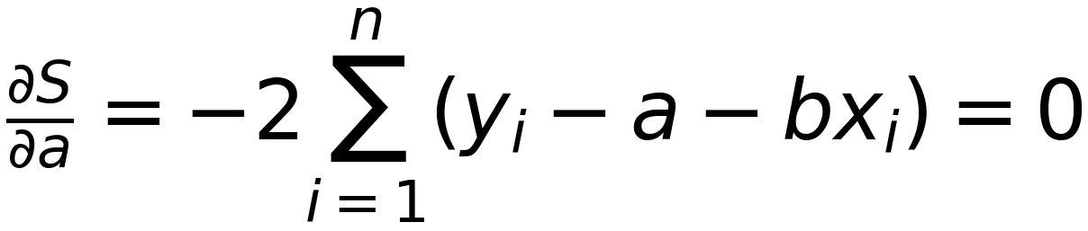
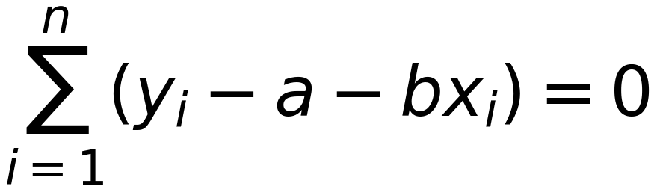
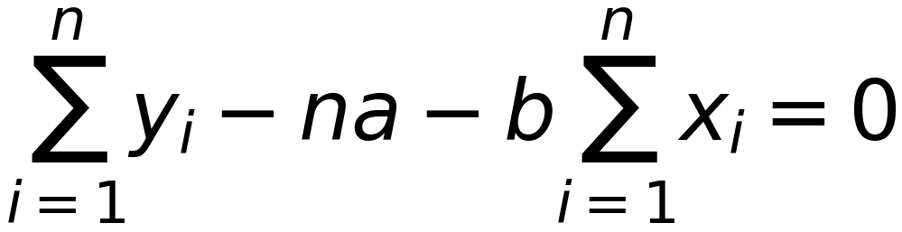
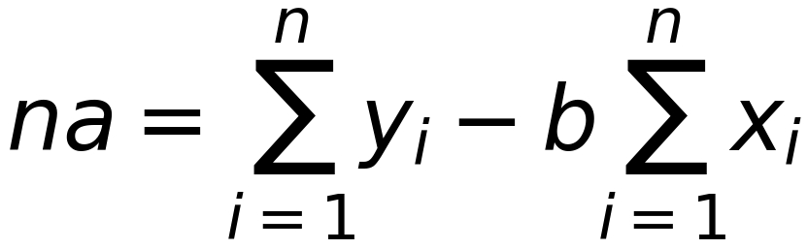
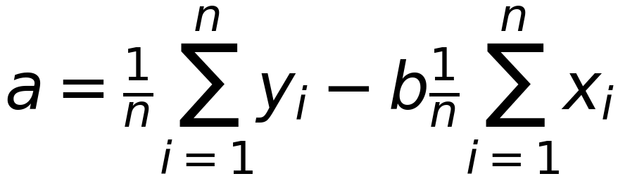
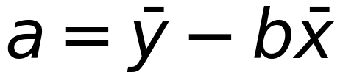
the closed-form solution is a = ȳ - b x̄

